Engineering Notebook

TEAM 271

ENED 1120 – 021

Dr. Cedrick Kwuimy

Project 5: Autonomous Record Retriever

Project date: Feb 2, 2020 to Feb 9, 2020

**Team members:**

John Cummings | cummijh

Nathan Damas |  damasnj

Bao Huynh | huynhlbg

Triet Pham | phamt7

**Goal:**

Bla bla bla.

// Table of contents page

# Meeting 1: Breaking down project 5

*Feb 12, 2020  
Langsam Library, 4pm – 6pm*

***Attendance:*** *Everyone*

|  |  |
| --- | --- |
| Task | Reflection |
| 1. Read and understand project 5’s description 2. Breaking down project 5’s needed components 3. Write test plan and document into a specification review file 4. Create Gantt chart for project 5’s management | 1. We summarized project’s requirements in a more understandable way and also highlight parts that we think need more clarification (details below) 2. We broke down project 5’s robots into 5 sub-components (details below) 3. We wrote repetition test plans for each component and make a specification review file (details below) 4. We created work breakdown structure, work precedence network, and Gantt chart for project 5 (details below) |

**Details:**

## 1. Understanding project 5

We managed to give a concise description of the robot’s purpose:

**The robot has one job: Given a barcode input, the robot must scan the whole arena until it picks up the box with the right bar code**

Additional clarification:

1. **What is a barcode?**

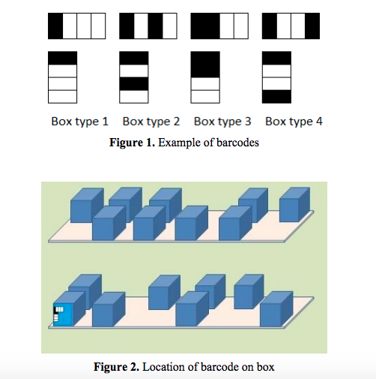

There will be 4 types of barcodes (meaning either there are duplicate barcodes, or somebox will have no code - **must ask more on RFAI**). Then scanning techniques is used to make sure that the box the robot will choose match with the input barcode

1. **What will the arena look like?**

This is the map of the final arena:

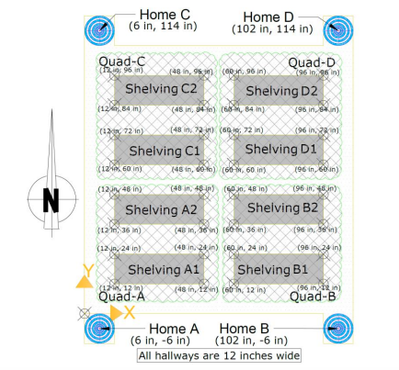

There are only shelves of boxes. No walls, no painted lines. Point A, C, D (not B) are Bluetooth transmission beacons that will help with robot’s navigation (more details below). Each shelf can contain a maximum of 12 boxes = 6 boxes * 2 row, but reality can be less than that (meaning that some box spot will be deliberately left empty).

1. **How will the searching process be monitored?**

Of course we can’t go and mess up all the boxes until we find the correct one.

There are 4 zones: A, B, C, D. At the demonstration, the coordinators will choose a starting zone for our robot (we can’t choose our starting place). Also, the robot must begin its searching in this order: **Zone A → B → C → D → A**. Meaning that, if we get assigned zone C as our starting point, we must first begin by searching zone C, then Zone D, then A, then B.

(The starting position is said to be RANDOM, but we are not sure how random is that: will it always be in the middle of a random zone, near a random shelf, or is it completely random and unpredictable? - ask more in RFAI)

Some more specific restrictions include:

* If the robot starts at zone A or D, it must first turn right into the hallway, and then search the shelf on its left first
* If the robot starts at zone C or B, it must first turn left into the hallway, and then search the shelf on its right first
* The robot must not touch any other obstacles (like random human walking in hallways, or other robot). And must not touch other boxes besides the correct one.

1. **How will the robot navigate?**

Using wheels and motors.

The system to help the robot determine where it is and where it has gone is called **Indoor PS** (or IPS or Indoor Positioning System). The way it works is: The robot will receive Bluetooth signal from point A, C, D and use that to **triangulate** its position. Mathematically, the strength of signal received will be processed to give us the robot’s distance to point A, C, and D and then we can determine its location on the grid.

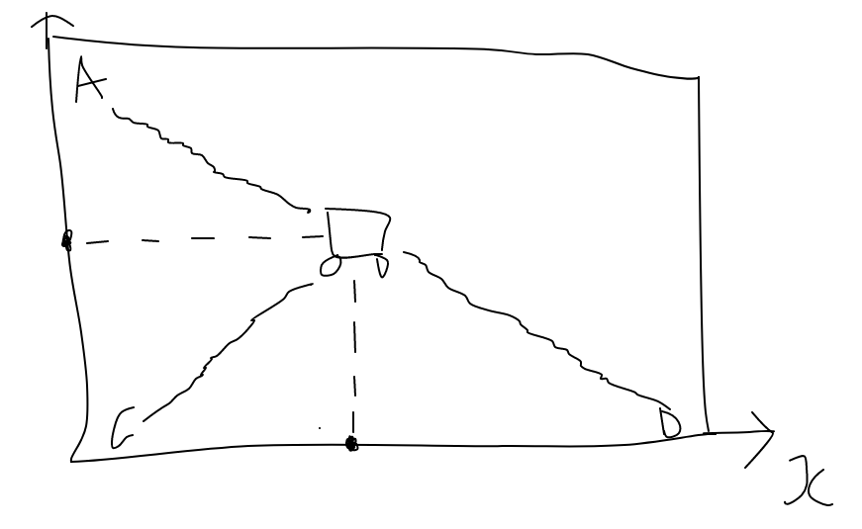

1. **How will the box look like?**

Dimension: Height: 6 in. ± 1.0 in.

Width: 3.785 in. ± 0.5 in.

Lifting Handle: A rigid handle approximately ½ inch wide is located approximately ½ inch above the box, centered and spanning the box width.

Weight: < 200 grams

Other Features: A small magnet glued on the inside center face of the box

1. **What to do after the robot has chosen the right box?**

Robot must then return to starting position to drop off and re-position to RECEIVE ANOTHER BARCODE

1. **What to do after the robot has chosen the wrong box?**

We don’t know

## 2. Sub-components:

After understanding about the robot’s purpose, we decided the robot should have the following four components:

1. Navigation system: The robot must first the able to move smoothly in the arena, so a navigation with wheels or treads is necessary
2. Barcode scanning system: The robot must be able to read the barcode correctly to get the right box
3. Pick up system: A good pick up system helps the robot retrieve a box surely (not dropping the box half-way) and in a timely manner. The system also manages dropping off the box when going back to the HOME location
4. Storage system: A storage system is necessary to ensure that the box is safe when transporting between location no matter how far. The system also ensures if anything happens, the box’s content shall remain intact
5. Localization system: A localization system with Bluetooth receiver help the robot triangulate its position to navigate the arena.

## 3. Testing plans:

Next, we developed testing plans for each function with specific numbers and parameters to make sure the above components work properly

1. Navigation system

* Minimum speed: 1 ft/s
* Be able to go forward perfectly straight – for 5 times in a row; will test with different distances from 1 to 10ft
* Be able to go backward perfectly straight – for 5 times in a row; will test with different distances from 1 to 10ft
* Be able to turn precisely with a displacement less than 3 inches – for 5 times in a row; will test with different angle from 45 to 270 degrees
* Each test above will be replicated on difference surface: carpet, paper, and tile

1. Barcode scanning system

* Barcode scanning maximum speed: less than 10s
* Be able to determine the right barcode type out of the 4 types – for 15 times in a row
* Be able to determine additional made-up barcodes as INVALID – for 15 times in a row

1. Pick up system:

* Be able to pick up maximum of 250g
* Be able to pick up boxes without dropping half-way successfully – for 10 times in a row, with boxes of different weights
* Be able to pick up boxes and put correctly in storage system and still able to move a small distance after that successfully – for 10 times in row; maximum time for this test must be less 10s for each repetition

1. Storage system

* Be able to carry object of maximum 250g without making the robot malfunction
* Be able to carry the object safely through a minimum distance 5 ft successfully – for 10 times in a row; will test for different speed: 1ft/s to 3 ft/s
* Be able to keep the object safe while robot spins at high speed for 10s

1. Localization

* Be able to display the correct (x, y) position of the robot – for 20 times in a row
* Be able to navigate between two coordinates precisely (with error < 5%) – for 15 times in a row; will test for different distances, including edge cases

## 4. Project management:

Based on the functional break down of the robot, we began project 5’s management with a work breakdown structure. We identified that the project will have three important phases:

I. Research phase: There are many important questions to explore to choose the optimal design for our robot: What factor contributes to the robot’s navigation problems (if any)? How does real-life barcode reader work and can we re-implement them here? What kind of picking machinery/designs is best for picking up boxes and how to not accidentally pick up the wrong box?, etc.

II. Building and testing phases: This is when all the research has been done, decision matrixes has been completed and we start to build the actual robot. We will build and test each component carefully before integrating the next components.

III. Post-demonstration phase: This is when the robot has finished and demonstration day has passed. The work left for us will include: Prepare for presentation, re-format engineering notebook, and write reports.

With these ideas in mind, below are the images of our Work breakdown structure, Work precedence network, and Gantt Chart. We estimated the project will be completed in 9 weeks:

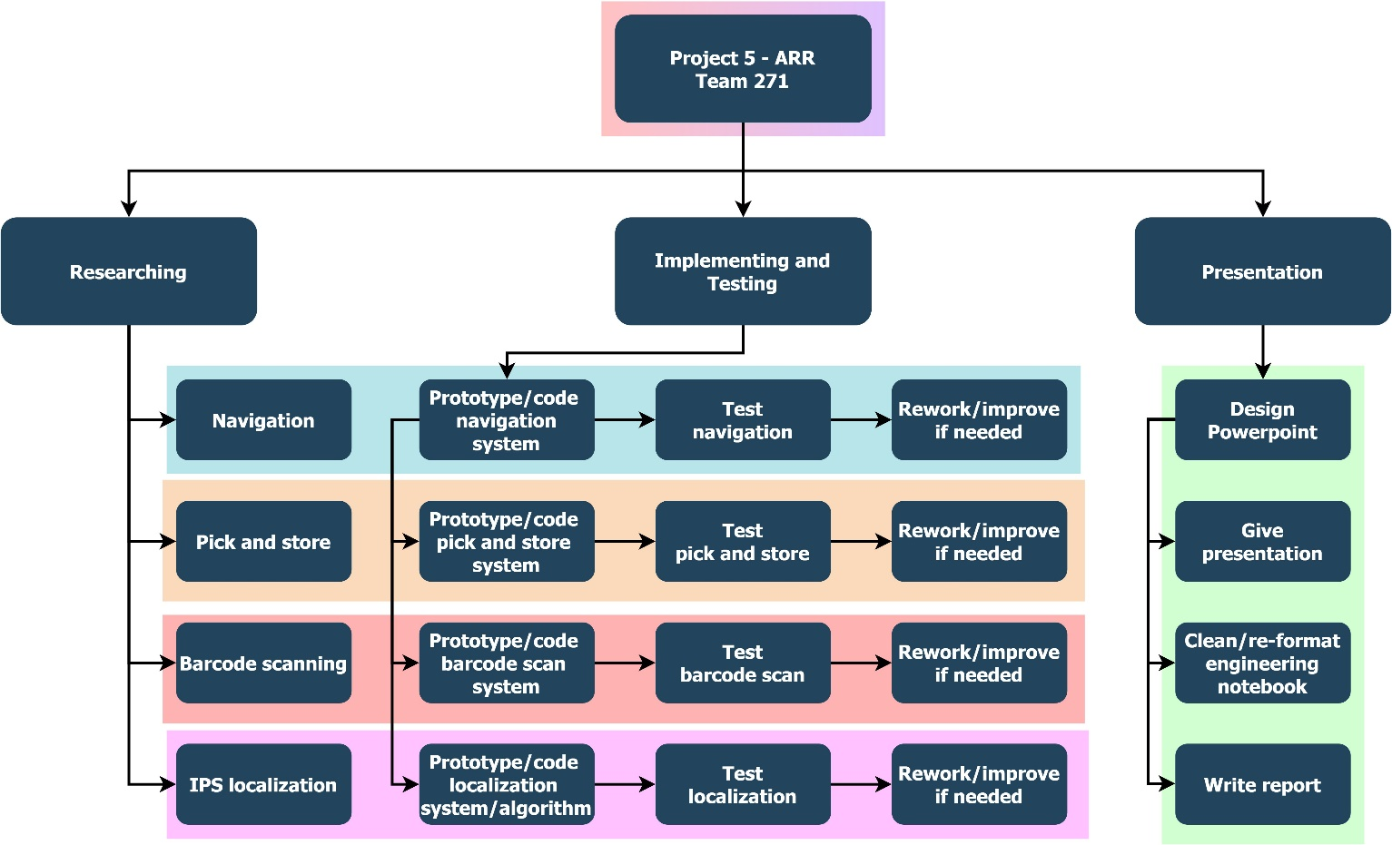

*(Image of Team 271’s work breakdown structure for project 5)*

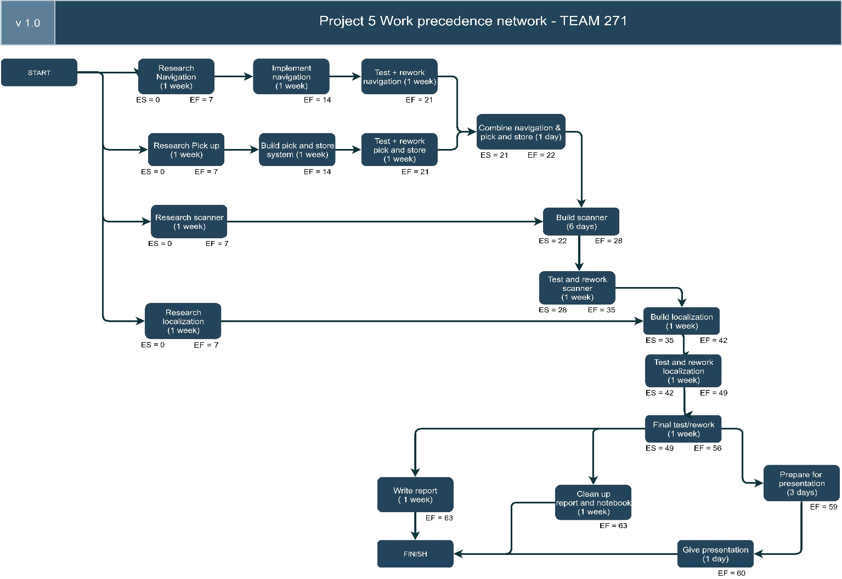

*(Image of Team 271’s work precedence network for project 5)*

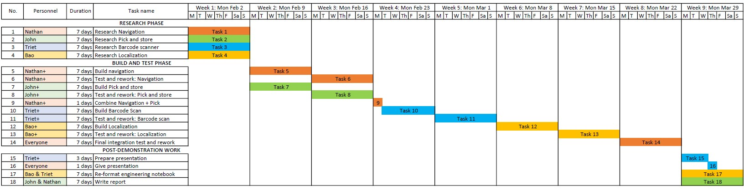

*(Image of Team 271’s Gantt Chart for project 5)*

# Meeting 2: Navigation system

*Feb 14, 2020  
Langsam Library, 4pm – 6pm*

***Attendance:*** *Everyone*

|  |  |
| --- | --- |
| Task | Reflection |
| 1. Brainstorm, choose idea, and prototype the robot’s navigation/movement system 2. Implement a program to make robot go forward and backward 3. Implement a program to make robot turn 180 degree 4. Test for robot speed | 1. We built a robot with 2 main wheels in front and a small metal marble to support the back (details below) 2. Our Python code implemented a PID algorithm with gyro sensor to help redirect the robot if it veers(details below) 3. Using gyro sensor readings, we programmed the robot to turn until a desired angle is reached (details below) 4. We tested with 20 trials, on tile and paper surface; the robot speed is determined to be 10cm/s (going forward) and 11cm/s (going backward) |

**Details:**

## 1. Robot prototyping:

After reading the descriptions of project 5, we understood that there would be no restrictions on the robot’s movement system, so we decided to use **wheels** as the mean of transportation. Wheels have the advantage of being easy to implement, easy to control, while also agile enough to allow robot to dodge obstacles in the arena.

As for how many wheels, we discussed and decided to go with 2 wheels because it is easier to implement and has less variability. There are only 2 motors so 4 wheels would mean involving gears or tread to connect the front and back part, and these systems have big variability being vulnerable to popping in and out.

However, upon building the two big wheels into the EV3 bricks and the two motors, we saw that our robot is falling downward at the back part because the two wheels assembled were at the front. Therefore, we revised our design to have a metal ball at the back, acting as a third wheel, to balance out the two wheels at the front, creating a strong triangular structure. The ball wouldn’t need a motor to function, so that is also a plus.

The final design of our robot navigation system is described in the image below:

<img>

## 2. Going straight:

<p>

## 3. Turning 180 degrees:

<p>

## 4. Determine the robot’s speed: